
Plated
Discover and share recipes from local chefs, friends, and family effortlessly based on your current pantry. Gain the technical skills to be self-expressive and independent in the kitchen.

Created By:
Maya A. (Designer & Developer), Emma M. (Designer & Developer), Ashley V. (Designer & Developer), and Graham G. (Designer & Developer)

Stanford University
CS 147: Human-Computer Interaction
Professor James Landay
December 11th, 2024

Table of Contents
Our Team
Problem/Solution Overview
Needfinding
- Interviews
- Synthesis
POVs & Experience Prototypes
- Final 3 POV Statements
- Sampling of the HMWs that stemmed from each POV
- Top 3 Solutions
- Brief Description of each experience prototype
Final Solution
Design Evolution
Values in Design
Final Prototype Implementation
Summary & Next Steps
Acknowledgments


OUR TEAM


Problem & solution overview

Problem:
Many amateur chefs find cooking to be a tedious chore that often takes longer than expected and lacks creativity.

Solution:
Plated addresses this by offering a curated selection of user-shared recipes tailored to individual preferences and available ingredients. Additionally, the app features an in-app virtual chef assistant, Chef Su, who provides guidance and answers common cooking questions. By fostering creativity and collaboration, Plated transforms cooking into a more enjoyable and accessible experience for chefs of all skill levels.

Needfinding
Through interviews with diverse participants, we explored the challenges and motivations of amateur cooks to uncover key insights that inform the design of effective cooking solutions.

Interviews
Three diverse participants were interviewed to understand the needs of amateur cooks. The first participant, Chef N, is a professional chef and teacher specializing in young adult cooking classes, who was recruited via a volleyball coach. Chef N provided expert insights on the experiences of beginner cooks and how to make cooking more approachable. The second participant, Travis, is a Stanford student-athlete with strict nutritional goals but minimal cooking experience. He was randomly recruited in the Athlete Dining Hall and represented an extreme user who rarely cooks. The third participant, a Philz Coffee customer, was a middle-aged mother randomly approached at a coffee shop. This participant offered perspectives on cooking for a family with limited skills or enjoyment. Interviews were conducted via Zoom (Chef N) or in-person (Travis and the Philz Customer), with granola.AI used for transcription in one case.

Synthesis
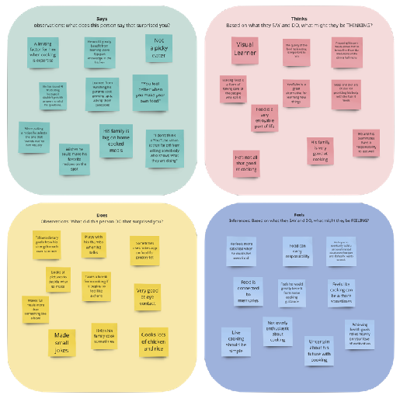
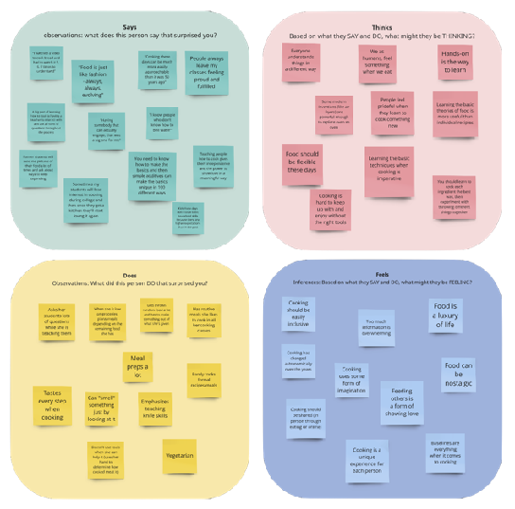
From the interviews, distinct patterns and needs emerged. Chef N emphasized the importance of accessible, flexible recipes that spark curiosity and allow cooking to become a form of self-expression. Travis highlighted the need for meal preparation to align with specific nutritional goals while being time-efficient and less of a chore. The Philz Customer shared the challenge of cooking as an unenjoyable task and stressed the importance of creating quick, easy meals that satisfy her family. These insights underscored that time, knowledge gaps, and motivation are significant barriers for amateur cooks, and solutions that simplify cooking while fostering creativity and enjoyment could be transformative.
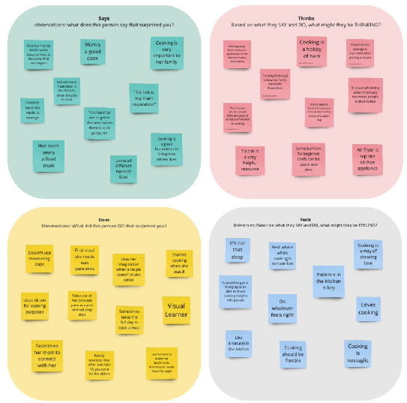

POVs & experience prototypes

Final POVs & their HMWs:
With insights gained from our interviews and some promising pain points/aspirations obtained from our interview analysis, we created POV statements for our most engaging interviews (Jad, Phillipa, and Travis), while also keeping in mind diversity of thought and background.

After we created each POV, we rapidly brainstormed 35 HMW statements for Jad, Phillipa, and Travis each. This was done in quick fashion to gather as many thoughts/ideas as possible, no matter how ridiculous each one was. We boiled down the 35 HMW per interviewee to the 2-3 most interesting, and from there brainstormed solutions. We came away with three viable solutions.

Jad: We met Jad, a recent post grad working in software consulting in the bay area, who is learning to cook for himself for the first time. We were surprised to notice that he loves to watch cooking videos, but finds it boring to take the time to learn the recipes himself. We wonder if this means that the stress & fatigue after the work day makes cooking not entertaining or enjoyable for him. It would be game changing to attract Jad to cooking for himself after work by unlocking the social element of cooking.
- HMW allow for socialization while cooking?
- HMW make cooking exciting?
- HMW make it easier to plan cooking around schedules?

Phillipa: We met Philippa, a mother of two from the bay area who cooks for a family of 4. We were surprised to notice that she doesn't enjoy cooking and doesn't plan out her meals. We wonder if this means she defaults to the same quick and easy meals that only her kids like to avoid extra stress. It would be game changing for her to use recipes that can satisfy everyone's food preferences while also giving a sense of joy for cooking. Transforming cooking into an avenue for creating happy memories with her family.
- HMW make cooking into a game?
- HMW make cooking a family activity?
- HMW help her not default to same recipes every week?

Travis: We met Travis, a Stanford student-athlete who has very specific dietary goals and mainly eats from the dining hall. We were surprised to notice that he feels more satisfied when he cooks his own food yet he still only gets his meals from the dining hall. We wonder if this means that having a stricter diet makes the cooking experience less exciting. It would be game changing if he didn’t have to stress about the nutrition elements of the recipes he’s cooking and instead could put effort into the fun, creative parts of cooking a meal.
- HMW make cooking feel rewarding?
- HMW make cooking fun and easy to learn?
- HMW make cooking with friends a shared experience?
- HMW create a sense of accomplishment after cooking?
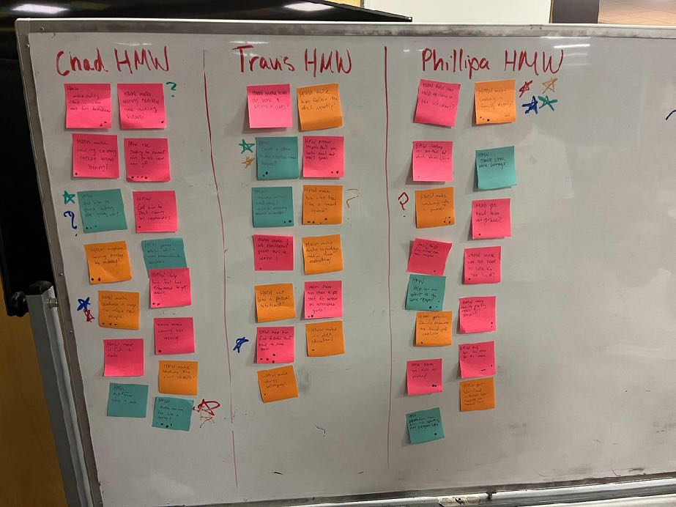

Final HMWs:
From the how might we’s from each point of view we were able to create some more robust HMW’s to lead our solution creation as follows:
HMW make cooking feel like a party?
- from Jad’s POV/Phillipa’s POV
HMW make cooking exactly like cooking videos?
- From travis’ POV
HMW reward creativity when cooking?
- From phillipa/travis POV

Top 3 solutions:
- Dinner Party Planning App
  - A Dinner Party Planning App that allows users to host virtual or in-person rotating dinner parties at different homes with culturally diverse menus, themed nights,. They have the option to cook together or split dishes among participants.
- Food tinder
  - Food Tinder is a social media app where users can share their cooking, swipe to save others' recipes based on preferences. They compete against friends for rewards like grocery credits and unlockable ingredients, and earn upgraded culinary rankings from line cook to executive chef
- Su Chef (helper bot)
  - Su Chef is a helper bot interface that answers cooking questions, organizes grocery lists for meals & roommates, transcribes cooking videos into recipes, and offers music playlists tailored to different recipes. SU chef is there to help with your cooking needs in the kitchen.

Experience Prototypes:
For each Experience Prototype we will speak on The assumption being tested, key aspects of the prototype setup, successes, shortcomings, and implications for the future. For each Experience Prototype, our participants were aged 18-25 and either post grad or college students with little cooking experience.
- Dinner Party Planning App
  - Key Assumption: People will think it’s more fun and less stressful to cook with family and friends
  - Process: Have participants call a loved one while cooking and make a meal with them over FaceTime.
  - Successes: Enjoyed having time within busy schedules to be doing an activity with his long distance girlfriend.
  - Shortcomings: Found it cumbersome to hold the phone while cooking as someone who doesn’t know how to cook to begin with.
  - Future: Interested to test further, but seems to add stress to the process.
- Food Tinder
  - Key Assumption: People would be excited about sharing their cooking and feel inspired by others’ plating images.
  - Process: Recruit experienced chefs to share images of nicely-plated dishes. Presented 10 images to beginner cooks in college, and have them “swipe” left or right on the image. Provide recipe if they swipe right!
  - Successes: “Knowing I inspired them to make something they wouldn’t have made is a great feeling.”
  - Shortcomings: Ensuring professional content.
  - Future: Interested in moving forward, want to explore participation inequality.
- Su chef
  - Key Assumption: People trust a chatbot with cooking advice/instructions
  - Process: participants dictate their ingredients/spices & receive a chatbot produced recipe to cook.
  - Successes: the recipe included new techniques & spices, which pushed her to be more creative with the ingredients she uses to makes pretty much the same meal every night,
  - Shortcomings: Found some of the cooking time inaccurate & there weren’t that many ingredients to work with so result was not overwhelming impressive.
  - Future: dive further into how the chatbot recipe would affect people who have more variable meal routines creatively and stress wise.

Design Evolution

Final Solution:
Our final solution, Plated, focuses on enhancing the cooking experience for amateur chefs by offering a curated selection of recipes based on their pantry items and preferences. The app empowers users to discover new recipes, manage their ingredient inventory, and even contribute their own creations, fostering creativity and independence in the kitchen. This solution reflects our mission to make cooking both enjoyable and accessible, addressing user frustrations with time-consuming and uninspiring meal preparation.
The evolution of our design stemmed from multiple iterations of prototypes and user feedback. Initially, we explored the potential of both mobile and augmented reality (AR) platforms, ultimately deciding on a mobile app for its accessibility and user familiarity. Our Experience Prototypes validated that users prefer intuitive, interactive interfaces for discovering recipes and managing pantry items, which influenced our design decisions throughout the development process.

Tasks:
Our solution grew into a user-friendly platform with three main tasks, each designed to meet different needs and keep users engaged in unique ways.

Task #1 (Simple): Swiping to Discover Recipes
The first task is a simple task which is swiping to discover recipes. This task focuses on enabling users to swipe through a curated selection of recipes tailored to their preferences and available ingredients. With inspiring creativity being a core value for our platform, we wanted the recipe cards to focus on the aesthetics and creativity of the plated meal. Users can easily browse recipes in a visually engaging, card-based interface, swiping up to skip or down to save a recipe in their saved recipes box. This simple and intuitive task is designed to make finding meal inspiration quick, fun, and low-effort. This task is important because many amateur cooks feel overwhelmed by decision fatigue or uninspired when it comes to planning meals. By incorporating a familiar swiping mechanic, users can quickly explore a variety of options without needing to make complex choices or scroll through long lists. It also ensures that users stay engaged with the app by making the discovery process enjoyable and dynamic.

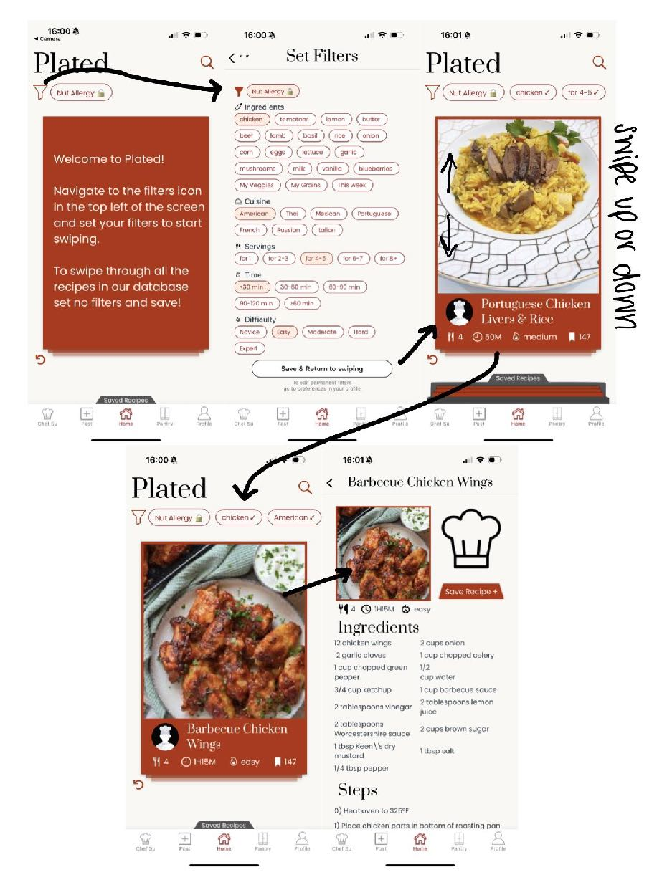
Task #2 (Moderate): Adding Items to the Pantry
The second is a moderate task which is adding items to the pantry feature. This task focuses on helping users keep track of the ingredients they have at home by adding items to their digital pantry. Users can manually input ingredients or select from commonly used items, making it easy to update their inventory. This task ensures that the app’s recipe suggestions are tailored to what the user can actually cook, creating a more personalized and practical experience. This task is important because many amateur chefs struggle with meal planning due to a lack of organization or not knowing what ingredients they already have. By maintaining an up-to-date digital pantry, users can avoid unnecessary trips to the store and reduce food waste, making their cooking experience smoother and more efficient.

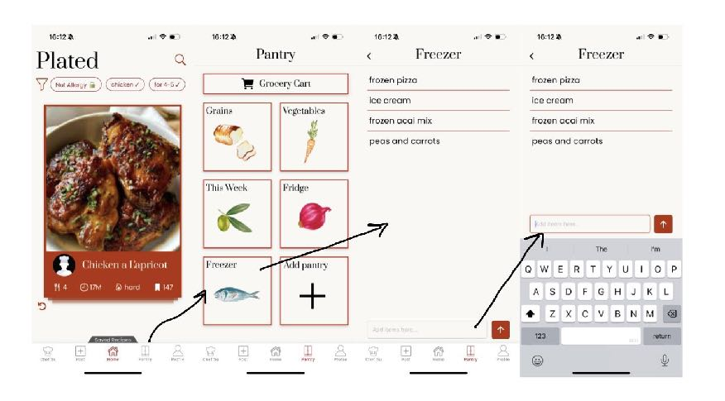
Task #3 (Complex): Uploading a Recipe
The third task is a complex task which is uploading a recipe. This task allows users to contribute their own recipes to the app by uploading detailed information, including ingredient lists, step-by-step instructions, and photos. Users are guided through the process with a clear and intuitive interface that provides templates and live previews. This ensures that even first-time contributors can successfully share their recipes with ease either via taking a direct photo or choosing a photo from their album. This task is important because it transforms users into active participants within the recipe creation community, fostering a sense of creativity, ownership, and connection. By giving users a platform to share their culinary ideas and experiences, the app not only enhances its recipe database but also strengthens its community-driven purpose.
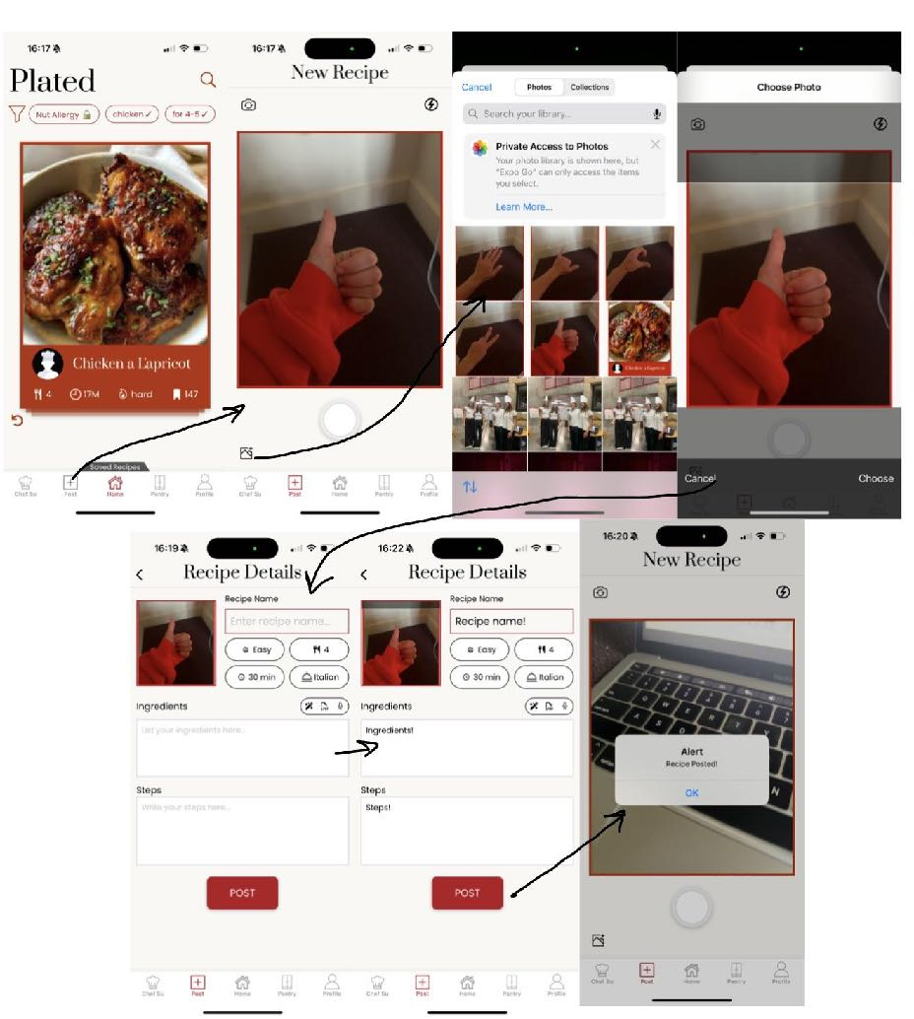

Design evolution visualization(s) and rationale:
Initial Sketches
In the initial sketching stages, we explored multiple methods of design such as mobile app, AR, VR, smart watch, and more. We narrowed the choice down to either a mobile app, offering a familiar and intuitive interface, or AR, which would allow the cooking assistant to be almost literally in the kitchen with you. After deliberating over the pros and cons, we chose to continue developing a mobile app interface.
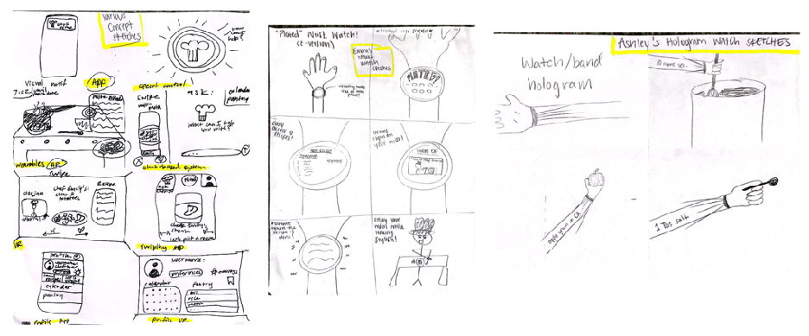
Concept sketches for mobile app, AR, VR, speech control, wrist watch, hologram watch
Low-Fi Prototype and Evaluation
We began sketching right away and created 21 screens that covered the functionality of our three task flows. These sketches were made in GoodNotes on an iPad to ensure readability and to allow for quick changes to be made in the design.
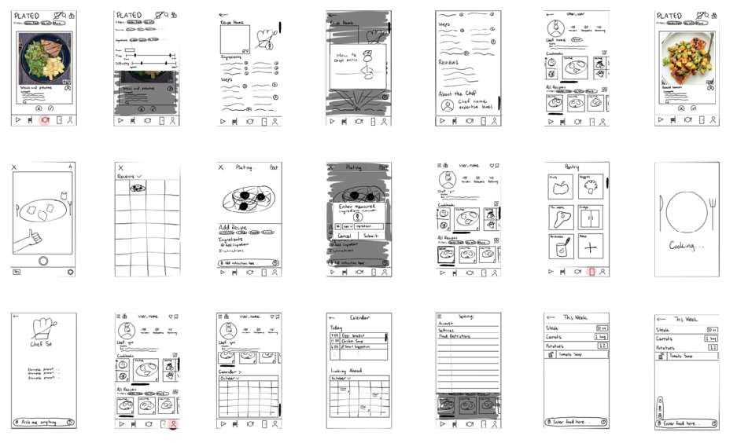
All 21 low-fi screens
With the low-fi prototype made, we conducted usability testing on four people from different demographics and with different backgrounds. These users consisted of a post grad working in a Stanford lab, a Stanford faculty member, a pro baseball player, and a post grad living in San Francisco. In addition to their feedback, we also measured their flexibility with the number of unique paths they could find to access a feature, and efficiency with the time they spent trying to recognize the task path. Their combined qualitative and quantitative insight was very helpful:
- Participants didn’t feel like they had a home base to go to
- Figuring out where to post was a deterrent, but generally easy once it was found
- Features in the footer were significantly easier to find
- Personalization was top of mind for most participants
- Had fun, but could be more efficient
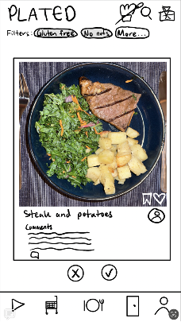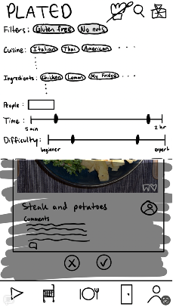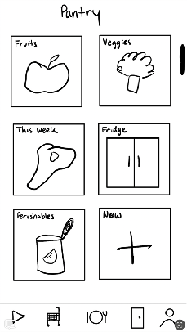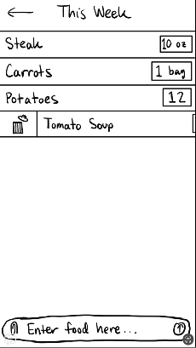
Example screens from the low-fi prototype (home, filters, pantry, pantry details)
As a result of usability testing, we changed three major aspects of our design. First, we switched the home screen icon to a figure that is intuitively “home” (ex. a house). Second, we added the posting feature to the footer buttons. Third, we guided users to personalization features right when they first get on the app by including a log-in flow. This feature was a great addition to the med-fi prototype, but it was not added to the high-fi as we were focused on high-level functionality. On top of these additions, we also added the grocery cart to the pantry page as a result of replacing it with the posting feature in the footer.

Medium-Fi Prototype and Evaluation
After we knew what we wanted to change, we got to work on the med-fi prototype using Figma. The results from usability testing were immediately implemented and highly effective in solving the problems our users revealed.
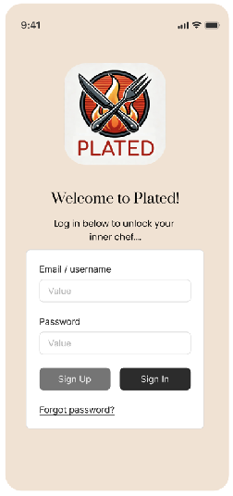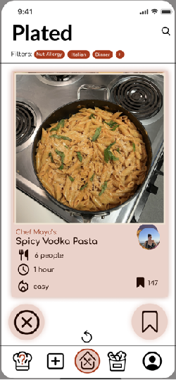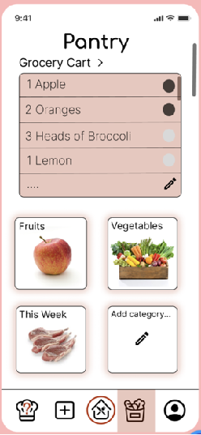
Beginning of log-in flow Added posting to footer, Grocery cart added to pantry
changed home icon to house
After creating the first half of our prototype in Figma, we got evaluated by HCI industry experts. They gave us many thoughtful design suggestions, most of which resulted in an overall shift in style. We got rid of a lot of our rounded elements, started utilizing a more vibrant color palette, and added more detailed cooking art to the pantry. This shift was largely reflected in our home and pantry screens, shown above before the expert evaluation and shown below after the expert evaluation.
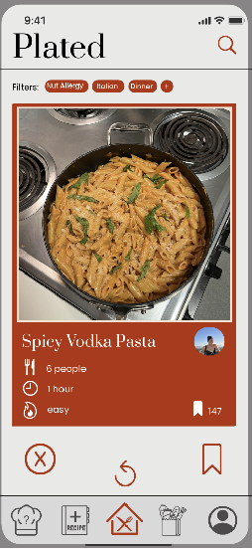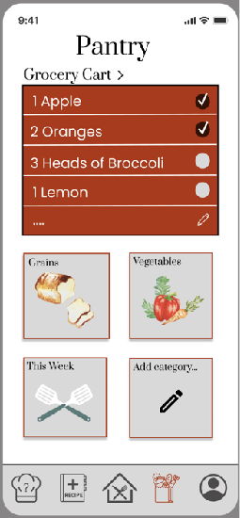
Darker red, Serif fonts, sharper edges, creative art, etc.
We then finished the second half of the prototype to round out the necessary task flows. Our next round of feedback came from other students in the CS 147 class in the form of a heuristic evaluation. In total, we had 62 violations with 20 being severity 3 and 14 being severity 4. The most common categories of violations were matching between the real world and the system, consistency and standards, flexibility and efficiency of use, and aesthetic and minimalist design.
- H1: Visibility of System Status - severity 3
  - The placement and no text near the circular picture may make it difficult for users to assume that it represents the profile picture of the recipe creator.
  - Our fix: we moved the profile picture to be grouped with the recipe text more so that it all seems related while also keeping the recipe card very simple
- H11: Accessible Design - severity 3
  - The filter selections and sliders are too small, making them hard to see and interact with for users with low vision or low touch sensitivity.
  - Our fix: make the filters displayed on home screen larger font and then we also will make the filters drop down work farther down so that the text can be larger
- H11: Accessible Design - severity 3
  - No 'see more' button for Recreation reviews or About the Chef after clicking on the recipe
  - Our fix: add a see more button that opens a modal pop up of the chef’s recreations or add some UI such that it is obviously pressable to see more
- H12: Value Alignment & Inclusion - severity 4
  - Current design assumes that the recipe speaks for itself, but most users may not recognize certain food names, like "Zuppa di Fagioli, which may exclude non-native users from fully understanding the recipe.
  - Our justification: this person didn’t read the readme which tells them to click the card to read more about the recipe
- H2: Match b/w System & World - severity 4
  - The two bold lines in the slider design are unclear, leaving users uncertain about their purpose and whether they represent a range, or how to change them. Does not match how sliders conventionally work.
  - Our fix: we will add lower and upper bound labels for the slider and color the range in between so it’s clear to the user
- H3: User Control & Freedom - severity 3
  - After clicking into a recipe from the main page, there's no way to approve or reject it (can only do it from the main swiping page without recipe details).
  - Our fix: add a button that lets user save a recipe from the recipe detail page
- H4: Consistency & Standards - severity 4
  - From the readme, swiping right and hitting save on a post should both "save" the post, but they are separate actions from the home page. The same applies for the "X" button, whose functionality overlaps with swiping left. Additionally, There is no way to follow a user whose recipe you see, but on the profile the number of followers and following is shown.
  - Our fix: we are not going to make the swiping left and right anymore, they will be swiping up and down into a recipe box
- H6: Recognition not Recall - severity 4
  - There is no clear indicator that you are able to swipe left or right, and is not intuitive from the prototype itself. There is a lack of visual confirmation that the user has saved or rejected a recipe when swiping.
  - Our fix: got rid of the two save icons and just have one now
- H6: Recognition not Recall - severity 3
  - Ingredients you have vs. not have are not listed
  - Our fix: ingredients that are in your pantry will not have a plus button to add to your grocery cart and ingredients that are not in your pantry will have a plus button.
- H7: Flexibility & Efficiency of Use - severity 3
  - The difficulty level slider in the filters is not intuitive and definition of 'easy' vs. 'hard' recipes is not clear
  - Our fix: we are making the sliders more clear with bounds
- H7: Flexibility & Efficiency of Use - severity 4
  - Nowhere to add 'Nut Allergy' and 'Dinner' customizable options in sections listed
  - Our fix: listed in the read me to set your permanent preferences like allergies or food restrictions in the profile preferences page.
- H9: Help Users with Errors - severity 3
  - We can increase accessibility for those that don't have certain ingredients. Easily finding substitutes for certain ingredients would be amazing
  - Our fix: users can ask for substitutions for ingredients using chef su AI helper
- H10: Help & Documentation - severity 4
  - No clear instructions on the wording for adding items in the pantry
  - Our justification: we have the instructions in the read me and are adding an onboarding task flow to specify this
- H2: Match b/w System & World - severity 3
  - Pantry tab collections (Grains, Vegetables) don't add up to what is in the entire Pantry collection
  - Our justification: not even really sure what this means and i just don’t think this was a well thought out HE
- H3: User Control & Freedom - severity 4
  - After adding an ingredient to the pantry, there is no way to remove it if it is depleted.
  - Our fix: we just hadn’t implemented this yet
- H4: Consistency & Standards - severity 4
  - The "PaperClip" Icon in the Pantry sections do not link to anything except for in the "This Week" part of the Pantry. However, after clicking on the paperclip attachment icon, then pressing the back button, it leads to the Chef Su screen rather than reverse it back to the previous screen of "this week Pantry".
  - Our fix: we just haven’t made it yet but we will make it link to something
- H4: Consistency & Standards - severity 3
  - Settings icon on Post page doesn't make sense intuitively -- settings for what?
  - Our fix: true, deleting
- H11: Accessible Design - severity 3
  - Chef Su features may be difficult to navigate for users who are unfamiliar with AI chatbot interfaces. The icon when clicking on a recipe is also confusing on whether or not it's a clickable button to redirect to Chef Su.
  - Our fix: Rephrasing the wording on the Chef Su page to “ask me your cooking questions”
- H1: Visibility of System Status - severity 4
  - Unsure what calendar feature on Profile is meant for (also not included in ReadMe).
  - Our fix: We decided the calendar is an unnecessary feature and have removed it
- H10: Help and Documentation
  - There is no menu explaining what each button throughout the app (on nav bar, in main page, etc) does.
  - Our fix: We are improving the wording in the README and are adding small titles to each button in the navigation bar to make it clearer what each symbol means
- H2: Match w system and world
  - Confusion about what cookbooks, all recipes, and recreations mean.
  - Our fix: We should change of cookbooks or make it more obvious that it is a category of recipes
- H7: Flexibility & Efficiency of Use
  - Restricts users from adding any content beyond the regulated ingredients and recipe, limiting creativity, personal expression, and flexibility.
  - Our fix: add a box where you can optionally describe the recipe or give some history/context
- H7: Flexibility & Efficiency of Use
  - The app lacks a clear way for users to input or adjust filters for difficulty, number of people, time, and cuisine, making it harder to customize recipe searches.
  - Our fix: We need to make it more obvious how users can add filters. We can make the button bigger and add text that says “add filters”
- H4L Consistency & Standards
  - Users are unsure whether they should use the same method as posting a new recipe for a recreation.
  - Our Fix: When adding your recipe, we will add a step asking if it is a recreation or new recipe OR
- H4 Consistency & Standards
  - Despite having filters available when swiping through recipes, when uploading a recipe there doesn't seem to be an option to add filters (except for cuisine)
  - Our justification: We have filters right there in the recipe posting and the nut free, etc will be determined by the ingredients you put in
- H3: User Control & Freedom
  - The user may be confused about how to insert steps and properly customize their recipe post
  - Our justification: it is pretty clear where the steps should be added and there is a text box that says “add steps here”
- H3: User Control & Freedom
  - There's a potential for a user to be posting a recipe with errors but the app lacks the ability to undo or edit after posting.
  - Our fix: Add an edit post button
- H2: Match w system and world
  - Clicking between "POST" and then clicking on the recipe again on the profiles page causes the user to go back to the "Plating..." page where you can post it once again
  - Our fix: Navigation bug will be fixed
- H2: match w world
  - After posting a recipe, the app lands on the Profile page.
  - Our justification: It goes to the page where you can see your most recent post
- H12: Value Alignment & Inclusivity
  - The design should encode values that users can understand and relate to, fostering inclusion and respect for diverse groups. Features like posting culturally specific recipes or unrestricted image sharing may unintentionally limit visibility or lead to negative social effects, potentially reproducing inequities. The design should prevent these issues, avoiding added burdens for disadvantaged users.
  - Our justification: There is gonna be moderation …..
- H1: Visibility of System Status
  - No notifications and action progress on what happens after posting
  - Our fix: We will be adding a “Post successful” notification
- H7: Flexibility & Efficiency
  - If the user is adding a bunch of items en masse, it's hard for them because they have to go into the individual categories to put them in
  - Our justification: users have control over how many categories they would like to have, so if they are bothered about having to add them to different categories, we assume they will not create the category in the first place
- H6: recognition not Recall
  - Current input structure allows for variation in how ingredients are listed (e.g., "30 eggs" versus "carrots"), so the system can't effectively match ingredients to recipes due to inconsistency in input formats.
  - Our fix: We will change it so that quantities are shown in the recipe
- H5: Error Prevention
  - Does not notify the user when an item is previously added to the list. Users are unaware if they have already added an item to the list, leading to potential errors and redundancy.
  - Our Fix: we will show how many items of x you have when you are adding it, you should still be able to add something you already have tho….
- H4: Consistency and standards
  - Users may be confused on what exact settings this toggles, especially with the three lines icon in the Profile. The differentiation between the two is unclear.
  - Our fix: Rename grocery cart to “Shopping List”
We spent a significant amount of time carefully going through each of these violations to make sure they got fixed. Some of the most notable changes can be seen in the home screen, filters screen, and recipe details screen.

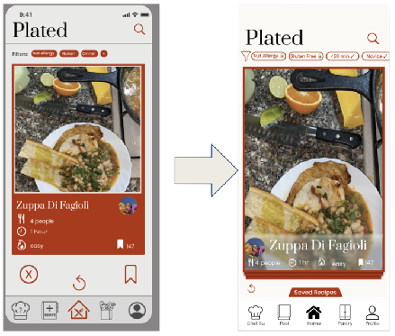
Note changes to navigation bar, swiping cards, saved recipes folder addition, and safe area view around the screen
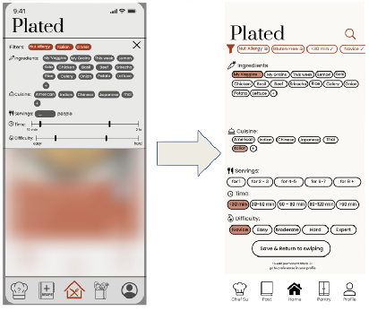
Note changes in colors, selection specification, permanent filters, and full screen view
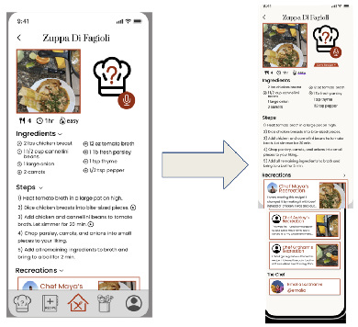
Note changes in background consistency, removed video buttons, save recipe button, clickable recreations, clickable chef profile
High-Fi Prototype
When designing our next iteration, we focused on staying in tune with all the suggestions we had received from our users, industry experts, and classmates. The high-fi prototype was coded through React Native and included almost every feature we initially set out to develop. Looking back, our UI went through many extremely helpful iterations and got better each step of the way.
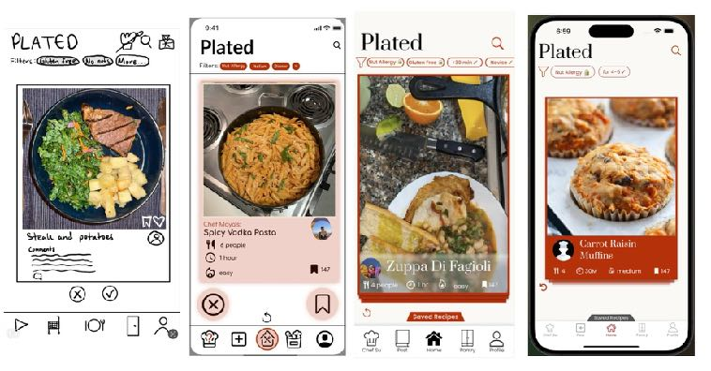
Home screen start to finish

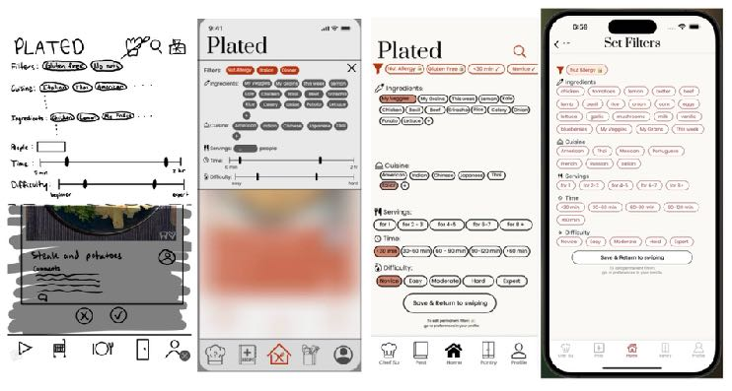
Filters screen start to finish

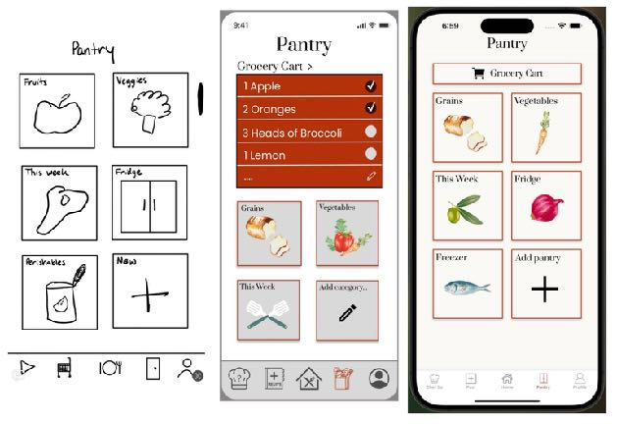
Pantry screen start to finish

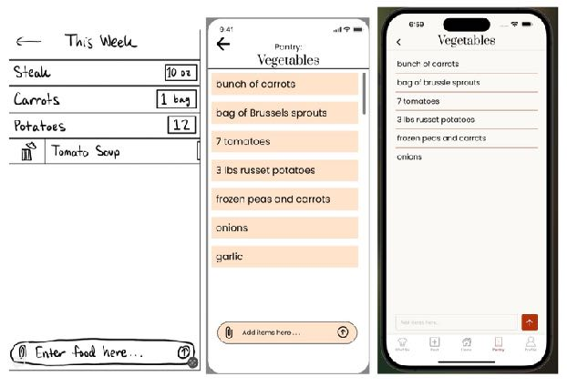

Pantry details screen start to finish

Values in Design:

Identified Values
Through our design process, we identified several key values that guided the development of Plated:
- Flexibility: Allowing users to tailor their cooking experience based on their needs, whether it’s discovering recipes, managing ingredients, or contributing their own creations.
- Creativity: Encouraging users to explore new recipes and experiment with cooking through collaborative features and shared inspiration.
- Food Safety: Ensuring users can easily account for allergies, dietary restrictions, and ingredient freshness. While also ensuring the safety of the cooking ingredients and instructions on user produced recipes.
- Organization: Helping users manage their pantry and plan meals efficiently to save time and minimize waste.
- Cultural Inclusion: Highlighting diverse cuisines and ensuring fair representation of cultural recipes.
- Sustainability: Promoting environmentally conscious choices, such as seasonal recipes and reducing food waste.

Embedding Values in our Solution
Each value is reflected in Plated’s core features:
- Flexibility: Users can swipe to discover recipes, manually update their pantry, or upload their own recipes, allowing them to engage with the app in the way that best suits their lifestyle.
- Creativity: The recipe upload feature encourages users to share their own dishes, fostering a community-driven platform that celebrates culinary exploration.
- Food Safety: Filters for dietary restrictions and allergens are integrated into the recipe discovery process to ensure a safe cooking experience for all users. If this app were launched at scale, we would implement content moderation, removing recipes with unsafe ingredients or instructions.
- Organization: The pantry management system helps users keep track of ingredients and expiration dates, reducing stress and simplifying meal preparation.
- Cultural Inclusion: Recipes highlight diverse cuisines, and the app design avoids cultural stereotypes to ensure an inclusive and respectful environment.
- Sustainability: Features like pantry tracking and ingredient-based recipe recommendations help minimize food waste. The app also suggests seasonal ingredients and local options for environmentally friendly cooking.

Value Tensions
During development, we encountered a few value tensions:
- Sustainability vs. Flexibility: While promoting sustainable cooking practices is important, we didn’t want to limit user choices by forcing them to adopt sustainable habits. To balance this, we provide optional recommendations for seasonal ingredients and local grocery options while still allowing users full freedom to select recipes and ingredients of their choice.
- Sensitivity vs. Creativity: Food is deeply personal, and while we want to foster creativity in recipe uploads and community interaction, we also need to ensure respect and sensitivity to diverse cultural and personal food preferences. If we were to scale our app to handle users, we would address this by implementing content moderation tools, allowing users to report insensitive content, and blocking harmful language while preserving freedom of expression.
By carefully considering and balancing these tensions, Plated maintains its commitment to its values while addressing the diverse needs of its user base.

Final Prototype Implementation:
Design Tools
We combined several tools to bring our app prototype to life. Starting with Notability, we sketched low-fidelity prototypes to brainstorm ideas and visualize the app's basic flow. Notability is a great tool for handwritten layouts and low-fi task flows. It’s less suitable for detailed design and having to re-create the sketches for the medium-fi led to some redundancy.
Once the layout and task flows were set, we moved to Figma, where we built a medium-fidelity prototype, refining key features and interactions. To create consistent and polished icons and logos, we used SF Symbols, aligning the design with iOS standards. Figma allows real-time collaboration for team members to work together, provide feedback, and iterate designs, which helped us with our overall efficiency. Figma also allowed us to implement user flows and interactions to test our task flows. The platform, however, has a steep learning curve, and it took us a week or two to get comfortable with more advanced features. Finally, while the medium-fi prototypes can be interactive, they don’t replicate the full functionality of the final product, leading to lots of small styling adjustments as we developed the hi-fi prototype.
From our figma prototype, we implemented our High Fidelity prototype in React Native using Expo Go simulator. We utilized Chat GPT to help us work through parts that were beyond our knowledge scope of react native. The codebase works on both iOS and Android, saving development time and resources. React Native also has an extensive set of libraries and community support to make it easier to integrate key features such as the swiping animation. Nevertheless, the learning curve still presented challenges as we started to familiarize ourselves with JavaScript, React, and Supabase. Debugging issues such as posting new recipes to the database or filtering through recipes took longer than expected, but help from 147L office hours and ChatGPT pushed us to the finish line.

Wizard of Oz Techniques
In our prototype, certain features are represented through Wizard of Oz techniques to illustrate intended functionality without fully building it out. We tell the user that you are able to ask Chef Su to do certain tasks based on your ingredients in your pantry or grocery cart. While chef Su is a fully Gemini AI API powered bot, it doesn’t have access to local or supabase user data such as the pantry or grocery cart.

These Wizard of Oz elements help us portray the prototype’s vision and user experience goals while keeping development focused on core interface flow.

Hard-Coded Items
Our final prototype includes a few hard-coded elements to streamline the demonstration and focus on the core functionality. For example, only the name and images are viewable for the recreations. Similarly, when users post recipes, only the recipe name and image are uploaded to the database. Ingredients, steps, and other variables are hard coded to ensure formatting stays consistent. Below is an overview of all of the hard coded items:

- Filter Options: When users select the filters from the home page, the options are static. Users cannot add options that we didn’t include or take any off. We hard coded these items to ensure output consistency when the filters are saved and the script to render the recipes with the selected filters runs. Similarly, the permanent filter is statically set with “Nut Free” to show users that they can add filters that always apply. To focus on every-day filtering, though, we do not let users change their permanent filters for the demo.
- Servings: To save time when creating the database, we hard coded the number of servings to be 4 for all recipes. We also do not pass in servings into the filters, to ensure that the stack of matching recipes is always large enough to allow swiping.
- Recreations: The Recreations do not have dynamic detail pages like the rest of the recipes. We view this feature as something to implement for future iterations of the app, but for now simply showing a list of recreations in the users page suffices in showing users that they have the option to recreate recipes and add their own personal touch.
- Posting Recipes: Currently, users can post recipes with an image. These are displayed in the profile page, but the recipe details page of posted recipes is not accessible due to string parsing issues we encountered. We instead allow users to scroll through the images and names of their posts, but they cannot access the details.
- Pantry: The data for the pantry is hard coded with two json files in the app that store the information for what is in your pantry. This allows users to simulate adding items, but saves us time from setting up a complete database that handles updating and removing items from your pantry. We view this as a secondary feature to recipe discovery, so simulating the experience with a hard-coded database is enough for users to understand functionality.
- User Profiles + Followers: The profiles of the logged in user (chef you) and of other users are hard coded to specific names with profile images imported into the app. We did not set up user authentication or management tables, but while using the app, the hard-coded profile pictures and names are displayed to match the experience of what it would look like with fully-developed user management systems. Similarly, the number of followers is set to a fixed value.

Reflection & Next Steps:

a. What were your main learnings from this quarter about the design thinking process, your studio theme, and your own project?
This quarter, working in the studio theme of design for healthy behaviors, we gained valuable insights into how thoughtful design can encourage users to adopt healthier habits—in our case, making cooking more approachable, enjoyable, and sustainable. Here are some of our main takeaways:
- Designing for Healthy Behaviors
A major focus of our studio theme was learning how to design products that promote positive lifestyle changes. For Plated, this meant addressing barriers that prevent amateur chefs from cooking at home, like decision fatigue, lack of organization, and the perception that cooking is time-consuming. By simplifying recipe discovery and providing tools for pantry management, we aimed to make cooking a more enjoyable and rewarding experience, helping users develop healthier cooking habits over time.
- Iterative Process Drives Results
The design thinking process showed us how crucial it is to start with user needs and iterate based on feedback. For instance, our early prototypes didn’t focus enough on simplicity, which led to confusion among testers. Through multiple iterations, we refined the app to focus on intuitive features like swiping for recipes and bulk pantry updates, which made the user experience much smoother.
- Foundation of Good Design [Empathy]
By interviewing and testing with our target audience—amateur cooks—we built empathy for their challenges. Users shared struggles like not knowing what to cook with the ingredients they had or feeling uninspired in the kitchen. This empathy helped us create features like ingredient-based recipe suggestions and allergy filters, which made the app more practical and supportive of healthier cooking behaviors.
- Balancing Features with Simplicity
We learned that designing for behavior change requires a balance between functionality and simplicity. While we wanted to include features like advanced filtering and community engagement, user testing reminded us to prioritize ease of use. Focusing on the core tasks—recipe discovery, pantry management, and uploading recipes—helped us avoid overwhelming users and keep the app effective.
- Team Collaboration and Iterative Feedback
Working as a team in a studio setting taught us the importance of collaboration. Each member brought unique perspectives, which helped us brainstorm better solutions and improve the app through shared feedback. Studio critiques pushed us to think more critically about how our design aligned with the theme of promoting healthy behaviors.

b. If you had more time, what might you add in the future?
If we had more time, we would add the following features to align Plated more closely with promoting healthy behaviors:

- Nutritional Insights: Include calorie counts, macronutrient breakdowns, and health tips for each recipe to help users make informed choices.
- Progress Tracking: Track users’ cooking habits, like frequency of home cooking or healthy recipe usage, to encourage consistency.
- Smart Meal Plans: Create weekly meal plans based on users’ dietary goals and pantry inventory to simplify healthy eating.
- Enhanced Pantry Management: Sync with grocery apps and offer tips for reducing food waste with leftover-based recipes.
- Beginner Tutorials: Add video guides and step-by-step instructions to support new cooks and build confidence.
These next steps would allow Plated to continue growing as a tool that inspires users to build healthy cooking habits, fosters creativity in the kitchen, and supports sustainability.

Acknowledgements
We would like to extend our heartfelt gratitude to Professor Landay, our course assistant Paige Olson, and the entire CS147 teaching team for their invaluable guidance and encouragement throughout this project. Their support and feedback played a crucial role in helping us navigate the design process and refine our solution. We are deeply appreciative of the learning opportunities and mentorship they provided during this journey.

